Rwanda CGE—treatment of indirect taxation specification suggestions (May 10, 2022)
This note sets out suggestions for modeling indirect taxation for Rwanda, which we hope are feasible and allow the envisaged policy analyses. The suggestions stay close to the IFPRI standard model, while drawing on the partial-equilibrium tax expenditure model of MINECOFIN (notably in/formal breakdown of commodity sales and VAT-exempted sales). The main changes vis-à-vis the July 2021 outline “New model equations” are: (a) using tax-exclusive composite commodity prices PQ and explicit layers of tax-inclusive PQ’s (first including excises, then also VAT); and (b) using in/formal and exempted/zero-rated shares in the prices of final demand and intermediate commodities.
The note sets out a possible treatment of VAT (section III.A-B), then adds excises (III.C-D), and brings in differentiated tax rates between domestic vs imported goods (IV). First, sections I-II sum up our model “indirect-tax desirables” and try to address more fully the IFPRI team’s earlier queries.
I. Model desirables for indirect taxation (VAT, excises, import duties) enabling GE analysis of
- tax expenditure, by simulating ‘fuller’ effective rates for import levies and VAT without exemptions
- the impact of changes in effective rates, i.e. in nominal rates for VAT and excises, in degree of informality/evasion, and in extent of exemptions/zero-rating (most commodities in 80-100 breakdown have a mix)
- indirect tax incidence (direct: on final sales, and indirect via inputs e.g. fuel, fertilizer, cement, cloth, …)
- impact of fuel taxation (excises, possible carbon tax,..) on commodity prices, demand and output
(not: impact of improving rebates since the system works okay, no need to model partial rebating)
II. Prior points from our earlier exchanges (cf. email June 20, 2021)
The VAT tax base for imported goods is the invoice import price CIF (Mombasa, Dar) plus import levies. Any transport/trade margin to sales point in Rwanda is subject to VAT the normal way.
Excises on imports are on the import price plus import duty; the VAT is on the import price plus duty plus levies (statistical, EAC,…) plus excises: pwm [ (1 + tm) (1 + texcm) + lev ] (1 + vatmeff). For simplicity, the levies may be lumped together with the import duty as has been done so far (with some loss in accuracy).
Excises are not rebatable/deductible, e.g. excises on intermediate fuel cannot be rebated, not even for exports. Airlines are exempted from excise on kerosene, or rather there is no excise on aviation kerosene.
The rebate system works well, except for intermittent delays in crediting (amounting to interest-free lending to government by the enterprise), so there is no need to model partial rebates.
The VAT is on private consumption and government consumption of G&S (purchases at tax-inclusive prices, while some government agencies can withhold indirect taxes on their purchases).
Investment goods are in principle exempt from VAT, but precise application depends on type of goods and investing sector, and some VAT gets levied on typical investment goods. Most imported investment goods are exempt of VAT; for domestic ones, VAT paid is deducted or tax credit given if considered as investment.
Exports are VAT zero-rated; import duties on imported inputs for exports can be rebated. Economic zones are exempt of import duties on inputs for exports. This is reflected in effective import duty rate by product.
The way the SAM captures indirect subsidies on air transport, electricity, water and hotels may need checking, as GFS ‘Taxes on goods and services’ does not net out these subsidies (in NA-NISR sense). Instead GFS has them under spending ‘Subsidies’. (Adjusting this would affect residual govt savings as calculated for the SAM, and the derived savings would be closer to government savings in GFS.) Only the electricity subsidies seem to be an indirect subsidy, the others direct subsidies.
Hence perhaps there is no need for modeling indirect taxes or subsidies on activities or commodities. If an indirect tax/subsidy is retained (e.g. for electricity), it may be treated as an excise (non-deductible).
III. Proposed treatment of VAT & excises in Rwanda CGE (VAT and excises on composite)
This section assumes that VAT and excises are levied on the composite (domestic-import) commodity, and VAT and excise rates are undifferentiated between domestic goods and imports as per end-June 2021 Rwanda (and standard IFPRI) model. This ‘restriction’ is relaxed in IV below with the outline of a complete, ideal case; however, it could be considered to leave its implementation for a later stage.
The IFPRI standard CGE has no VAT, but a sales tax on commodities; almost all prices in the equations affecting production decisions are excluding sales tax, except intermediate input prices which include (non-deductible) sales tax (eq. 7-8). The outline “New model equations” with VAT keep this approach, but seems to run into difficulties when it comes to deduction of VAT on inputs. It appears that an explicit treatment of taxes on intermediate and final sales, exemptions and in/formal sections, and a transparent treatment of tax exclusive/inclusive commodity prices PQ would be warranted.
The standard CGE does not have excises, though the sales tax could capture them. However, excises (esp. on fuel) require special treatment, also as it is the only tax on fuel (subsuming import duty, VAT, and ‘true’ excise) and is not deductible if used as intermediate input. Excises are treated in C-D below.
- Treatment of VAT on commodities (‘normal’ case, incl. zero-rated final sales, formal)
We first define a tax-exclusive composite demand price PQ_{c} (eq. numbers refer to standard model):
PQ_{c} QQ_{c} = PDD_{c} QD_{c} + PM_{c} QM_{c} (4a) with PDD_{c} tax-exclusive price, PM_{c} only import-tax-inclusive
Then we define the VAT as a mark-up to derive the tax-inclusive composite (Final) price PQ_{c}^{F}
PQ_{c}^{F} = PQ_{c} (1 + vateff_{c}) (4b)
This brings out VAT as a tax on private consumption, with PQ_{c}^{F} entering final demand equations. The tax-exclusive composite demand price remains PQ_{c} and works through all equations in the standard model.
The VAT rate applicable to final sales is the effective VAT, i.e. well below 18% by taking into account any non-collection because of informal sector, evasion etc., and exemption/zero-rating. The effective VAT rate on final consumption of commodity c can be calculated in two ways:
- from the data (SAM) as VAT collected divided by [consumption (private and government) minus VAT collected], with the effect of in/formal, exemptions etc. implicit;
- by applying shares of formal, exemption and zero-rated transactions, from NISR- SUT and RRA data in an 80 commodity/sector breakdown as extracted from the Tax Expend. model (see Tables 1-2 in Annex below and the attached XLS file).
The second way estimates the effective VAT rate for final demand of commodity c as:
vateff_{c} = ( 1 - λ_{c} - μ_{c} ) ε_{c} vat_{c} where: λ_{c} exempted share and μ_{c} zero-rated share in formal section,
ε_{c} share of formal section, vat_{c} VAT rate (normally 18%)
The RRA-provided shares are calculated as a fraction of total commodity supply (domestic output plus imports incl. trade margins), with all imports considered as formal.
With this modification, all prices PQ in the set of equations for productive decisions will be excluding VAT, starting with PDD, PDS, and PX (eq. (3-5), then PXAC, PA, and PVA (eq. 20, 6, and 7-8). Also, intermediate input prices will be excluding VAT in eq. 7 (determining PVA in eq. 8) because VAT on inputs is deductible and the VAT weighs on the final demand price.
By reformulating eq. 7-8 a bit (with PA_{a} fully determined in successive steps by tax-exclusive prices PDD_{c}), the value added price for activity _{a} becomes (a few commodities c are made by activity a):
PVA_{a} = PA_{a} [PDD_{c} c by a] - ∑_{c’} A_{c’c} PQ_{c’} (7-8a)
Value added price VAT-excl. VAT-excl.
excl. end-VAT prices input price
This covers well a formal system (as if there is no VAT on inputs) and works for both normal and zero-rated commodities, as VAT on inputs is deductible. However, we need to address the issues of: (i) input purchases by the informal sector from the formal sector; and (ii) (partially) exempted final consumption commodities. In both cases, the VAT on inputs is not deductible, affecting the PVA for production decisions (eq. 7-8) as well as government revenue. It is for this reason that the layers of commodity prices—PQ (tax-exclusive), PQ^{A,} PQ^{B}….. (for intermediates), and PQ^{F}(final demand) by the taxes they include—seem important for the model to have.

- Treatment VAT on commodities (VAT on certain inputs not deductible: in/formal and VAT exemption)
In/formal. To deal with the VAT on inputs paid but non-deductible, we introduce the formal “section” share in sales by commodity, as estimated in NISR-SUT: ε_{c} . This formal share is assumed to apply uniformly to all its sales on the demand side, including sales of intermediates. It also applies to its purchases on the supply side, where a fraction ε_{c} of intermediate demand for any input commodity c’ comes from the formal section and (1- ε_{c}) from the informal section; an example could clarify this:
Suppose the informal section share is (1 - ε_{c)} = (1 – 0.4) = 0.6 on the purchaser side and it buys inputs c’ from sellers of intermediates where the formal section share is ε_{c’} = 0.75. The purchases by the informal purchaser from the formal seller are subject to non-deductible VAT:
<--VAT-inclusive input price PQ_{c’}^{A}-->
PVA_{a} = PA_{a} [PDD_{c} c by a] - ∑_{c’} A_{c’c} PQ_{c’} ( 1 + (1 - ε_{c}) ε_{c’} vat_{c’} ) (7-8b)
Value added price VAT-excl. VAT-excl. informal section c purchases
excl. end-VAT prices input price from formal section c’ including VAT
In the example, a fraction 0.6 of intermediate purchases of c’ is subject to non-deductible VAT at the effective rate vateff_{c} = ε_{c’} vat_{c’} = 0.75 * 0.18= 0.135. The overall non-deductible VAT rate on input c’ purchases by c is:
(1 - ε_{c}) ε_{c’} vat_{c’} = 0.6 * 0.75 * 0.18 = 0.081. And similarly for all intermediate c’.
VAT exemption. The second issue is that for VAT-exempted commodities, the intermediate inputs need to include VAT even for formal section purchases, because no VAT on inputs can be deducted. As introduced above, the share of formal section final sales of commodity c that is exempted is λ_{c} (Table 2, Annex). The intermediate purchases by the exempted formal section become subject to non-deductible VAT:
<--VAT-inclusive input price PQ_{c’}^{B} if c exempt-->
PVA_{a} = PA_{a} [PDD_{c} c by a] - ∑_{c’} A_{c’c} PQ_{c’} ( 1 + [ (1 - ε_{c}) ε_{c’} + λ_{c} ε_{c} ε_{c’}] vat_{c’} )
Value added price VAT-excl. VAT-excl. informal section c purchases
excl. end-VAT prices input price from formal section c’ including VAT
= PA_{a} [PDD_{c} c by a] - ∑_{c’} A_{c’c} PQ_{c’} ( 1 + [ 1 - (1- λ_{c}) ε_{c} ] ε_{c’} vat_{c’} ) (7-8b’)
non-exempted effective VAT rate input c’
formal section c purchases
are VAT deductible
where λ_{c} ε_{c} the share of the exempted formal section for commodity c
If commodity c formal section is fully exempt, λ_{c} =1, equation (7-8b’) becomes:
<--VAT-inclusive input price PQ_{c’}^{B} if c exempt->
PVA_{a} = PA_{a} [PDD_{c} c by a] - ∑_{c’} A_{c’c} PQ_{c’} ( 1 + ε_{c’} vat_{c’} ) (7-8b”)
Here all formal section c purchases of inputs from formal section c’ are subject to VAT at the effective VAT rate for c’. Using the same example as above: ε_{c’} vat_{c’} = 0.75 * 0.18= 0.135.
In both above cases, total government VAT revenue from non-deductible intermediate sales is:
∑_{c} X_{c} ∑_{c’} A_{c’c} PQ_{c’} [ (1 - ε_{c}) ε_{c’} + λ_{c} ε_{c} ε_{c’}] vat_{c’} = ∑_{c} X_{c} ∑_{c’} A_{c’c} PQ_{c’} [ 1 - (1 - λ_{c}) ε_{c} ] ε_{c’} vat_{c’} (37a)

- Addition of excises/subsidies on commodities (normal case, incl. zero rated final sales, formal)
The exposition of the treatment of excises would normally precede that of VAT because VAT is normally charged on excises (except for fuel) and excises are non-deductible (neither on intermediates, e.g. fuel, milk powder, nor on investment goods, e.g. vehicles). For presentation purposes, we started with the VAT (subsections A-B), and we now add excises (subsections C and D).
Excises are appropriately formulated ad valorem, even if they are specific. Using a modification of the standard model sales tax (eq. 4), we define the excise-inclusive composite demand price as a mark-up on the tax-exclusive composite demand price, i.e. PQ_{c} ( 1 + texeff_{c}).
For indirect subsidy commodities, we can use tex_{c} as the (negative) rate of subsidy in percent of the pre-tax composite price PQ. Like excise tax, a subsidy on an input is not deductible for VAT purposes!
The all-tax-inclusive composite final demand price becomes (with VAT typically calculated on the excise):
PQ^{F}_{c} = PQ_{c} (1 + texeff_{c}) (1 + vateff_{c}) (4c)
The effective excise and VAT rates for composite final demand are:
texeff_{c} = ε_{c} tex_{c} assuming excises applied to formal section, but not to informal section
vateff_{c} = ( 1 - λ_{c} - μ_{c} ) ε_{c} vat_{c}
where: λ_{c} exempted share and μ_{c} zero-rated share of formal section, ε_{c} share of formal section,
vat_{c} VAT rate (normally 18%), tex_{c} excise rate

As in subsection A, the tax-exclusive composite demand price PQ works through all equations in the standard model, including in eq. 7- 8 for the PVA.
For intermediate inputs, the excise-inclusive price applies because excises are non-deductible for VAT purposes (e.g. fuel excises and any carbon tax):
<--excise-inclusive input price PQ_{c’}^{C}-->
PVA_{a} = PA_{a} [PDD_{c} c by a] - ∑_{c’} A_{c’c} PQ_{c’} (1 + tex_{c’}) (7-8c)
Value added price Tax-excl. Tax-excl.
excl. end-tax prices input price
As in subsection A, this holds well for the formal VAT system (as if there is no VAT on inputs) but does not take into account non-deductible VAT on input purchases either by the informal section from formal sections or for the production of VAT-exempted commodities. Hence this subsection is for exposition only and we turn to the more relevant case of non-deductible VAT on inputs in the next section.
- Treatment VAT and excises (VAT on certain inputs not deductible: in/formal and VAT exemption)
As in Section B, we need to deal with VAT paid on inputs which is not deductible either because of informality or VAT exemption of final sales, with the use of formal shares ε_{c} for domestic sales and purchases by commodity. As above, excises apply only to the formal section.
For brevity, we directly go to the formulation which captures both in/formal issue and the VAT exemption of final sales. With λ_{c} denoting the share of formal section sales of commodity c that is exempt, the new version of equation (7-8b’), now including excises, becomes:
<-----Tax-inclusive input price PQ_{c’}^{D} if c exempt---->
PVA_{a} = PA_{a} [PDD_{c} c by a] - ∑_{c’} A_{c’c} PQ_{c’} (1 + ε_{c’} tex_{c’} ) ( 1 + [ (1 - ε_{c}) ε_{c’} + λ_{c} ε_{c} ε_{c’}] vat_{c’} )
Value added price Tax-excl. VAT-excl . excises on informal section c purchases
excl. end-tax prices input price formal purchases from formal section c’ including VAT
= PA_{a} [PDD_{c} c by a] - ∑_{c’} A_{c’c} PQ_{c’} (1 + ε_{c’} tex_{c’} ) ( 1 + [ 1 - (1- λ_{c}) ε_{c} ] ε_{c’} vat_{c’}) (7-8d’)
non-exempted effective
formal section c purchases VAT rate input c’
are VAT deductible
where λ_{c} ε_{c} the share of the exempted formal section for commodity c
If the formal section of commodity c is fully exempt (λ_{c} =1), equation (7-8d’) becomes:
<--VAT-inclusive input price PQ_{c’}^{D} if c exempt->
PVA_{a} = PA_{a} [PDD_{c} c by a] - ∑_{c’} A_{c’c} PQ_{c’} (1 + ε_{c’} tex_{c’} ) (1 + ε_{c’} vat_{c’} ) (7-8d”)

Equations (4c) and (7-8d’) show that effective VAT taxation by commodity is different for final demand and intermediate sales, due to purchases by the informal sector and exemptions.
Government revenue from VAT & excises: on final & intermediate sales (revised eq. 37)
As case D is the most comprehensive, we now formulate government revenue, and compare two ways of calculating the effective rates.
On final demand for commodity c’
PQ^{F}_{c’} (QH_{c’} + QG_{c’}) = PQ_{c’} (1 + texeff_{c’}) (1 + vateff_{c’}) (QH_{c’} + QG_{c’})
vateff_{c’} = (1 - λ_{c’} - μ_{c’} ) ε_{c’} vat_{c’} and texeff_{c’} = ε_{c’} tex_{c’}
Excise revenue final sales commodity c’: PQ_{c’} ( ε_{c’} tex_{c’} ) (QH_{c’} + QG_{c’}) = EXC-F_{c’} (37a)
VAT revenue final sales commodity c’: PQ_{c’} (1 + ε_{c’} tex_{c’}) (1 - λ_{c’} - μ_{c’}) ε_{c’} vat_{c’} (QH_{c’} + QG_{c’}) = VAT-F_{c’}

On non-deductible intermediate sales, for commodity c’
Excise revenue intermediate sales c’ ∑_{c} X_{c} A_{c’c} PQ_{c’} ε_{c’} tex_{c’} = EXC-A_{c’} (37b)
VAT revenue intermediate sales c’ ∑_{c} X_{c} A_{c’c} PQ_{c’} (1 + ε_{c’} tex_{c’}) [ 1 - (1 - λ_{c}) ε_{c} ] ε_{c’} vat_{c’} = VAT-A_{c’}
For the base year, adjustment factors are calculated to mark up the tax rates such that calculated collection equals tax collection in the SAM by commodity:
δvat_{c’} = (SAM VAT collection c’) / (VAT-F_{c’} + VAT-A_{c’} ) (37c)
δexc_{c’} = (SAM EXC collection c’) / (EXC-F_{c’} + EXC-A_{c’} )
The adjustment factors are incorporated in the adjusted VAT and excise rates:
vat_{c’} = δvat_{c’} vat_{c’} and tex_{c’} = δexc_{c’} tex_{c’} (37d)

IV. Proposed complete option—VAT & excises differentiated for domestic vs imported commodities
So far we have assumed that VAT and excises are on the composite (domestic-import) commodity, and the tax rates are undifferentiated between domestic and imported commodities (the IFPRI standard and end-June 2021 Rwanda model). A differentiated treatment would be appropriate because the effective VAT and excise rates are different and subject to different tax policy and administration measures.
If a differentiated treatment were feasible to program in GAMS as indicated in James’ July 8 note and the moment to do so were opportune, we would suggest following the same approach as above, i.e. with most prices in the model being tax-exclusive (except for intermediate prices in eq. 7-8) and defining first the tax-exclusive composite demand price PQ as the reference price, and various tax-marked-up prices.
From the standard model, we keep the tax-exclusive composite commodity final demand price PQ_{c}:
PQ_{c} QQ_{c} = PDD_{c} QD_{c} + PM_{c} QM_{c} (PM includes import duties) (4a)
We then derive tax-inclusive prices via implicit tax rates for the composite final demand commodity, in two steps; first for excises to calculate the composite excise rate (now a model variable, no longer a parameter):
PQ_{c} (1 +TEXCOMP_{c}) QQ_{c} = PDD_{c} (1 + ε_{c} texd_{c}) QD_{c} + PM_{c} (1 + ε_{c} texm_{c}) QM_{c} (4b)
Where: ε_{c} texd_{c} and ε_{c} texm_{c} effective excise rates on domestic and imported commodities
Then for excises and VAT to calculate the composite VAT rate (also now a model variable):
PQ^{F}_{c} QQ_{c} = PQ_{c} (1 + TEXCOMP_{c}) (1 +VATCOMP_{c}) QQ_{c} =
= PDD_{c} (1 + ε_{c} texd_{c}) (1 + (1 - λ_{c} - μ_{c}) ε_{c} vatd_{c}) QD_{c} + PM_{c} (1 + ε_{c} texm_{c}) (1 + (1 - λ_{c} - μ_{c}) ε_{c} vatm_{c}) QM_{c} (4c)
Where: (1-λ_{c}-μ_{c}) ε_{c} vatd_{c} and (1-λ_{c}-μ_{c}) ε_{c} vatm_{c} effective VAT rates on domestic and imported commodities
The composite excise and VAT rates calculated in eq. (4c) would need to be recalculated for each iteration, as are anyway volumes and prices. Eq. (4c) also derives the composite tax-inclusive final demand price, PQ^{F}_{c}.

Similarly, the composite VAT rate on intermediates VATCOMP^{A}_{c} is calculated from:

PQ_{c} (1 + TEXCOMP_{c}) (1 + VATCOMP^{A}_{c}) QQ_{c} =
= PDD_{c} (1 + ε_{c} texd_{c} ) (1 + ε_{c} vatd_{c} ) QD_{c} + PM_{c} (1 + ε_{c} texm_{c}) (1 + ε_{c} vatm_{c}) QM_{c} (4c)

Complete case D: VAT and excises (VAT on certain inputs not deductible: in/formal and VAT exemption
Using this directly for case D, above equation (7-8d’), now with composite excise and VAT rates, becomes:

<-----Tax-inclusive input price PQ_{c’}^{D} if c exempt---->
PVA_{a} = PA_{a} [PDD_{c} c by a] - ∑_{c’} A_{c’c} PQ_{c’} (1 + TEXCOMP_{c’}) (1 + [1 - (1- λ_{c}) ε_{c} ] VATCOMP^{A}_{c’}) (7-8d’)
Value added Tax-excl. tax-excl. non-exempted effective
price excl. prices input price formal section c purchases tax rate input c’
end-tax are VAT deductible
where: λ_{c} ε_{c} the share of the exempted formal section for commodity c

If the formal section of commodity c is fully exempt (λ_{c} =1), equation (7-8d’) becomes:
<--VAT-inclusive input price PQ_{c’}^{D} if c exempt->
PVA_{a} = PA_{a} [PDD_{c} c by a] - ∑_{c’} A_{c’c} PQ_{c’} (1 + TEXCOMP_{c’}) (1 + VATCOMP^{A}_{c’}) (7-8d”)

Government VAT and excise revenue:
The government revenue are as the revised eq. 37 in subsection D above. Total revenue is calculated by substituting TEXCOMP_{c’} and VATCOMP_{c’} for ε_{c’} tex_{c’} and (1 - λ_{c’} - μ_{c’} ) ε_{c’} vat_{c’} for final sales (37a)
And by substituting TEXCOMP_{c’} and VATCOMP^{A}_{c’} for ε_{c’} tex_{c’} and ε_{c’} vat_{c’} for intermediate sales (37b)
Similarly, for the base year adjustment factors are calculated to mark up the tax rates such that calculated collection equals tax collection by commodity in the SAM.
Import demand equation:
One more price equation needs adjustment because of differentiated tax rates on domestic and imported commodities, i.e. the relative import vs domestic price eq. 25, which can no longer ignore taxation, so:
Relative price PDD_{c} /PM_{c} becomes: PDD_{c} (1 + ε_{c} texd_{c})(1 + ε_{c} vatd_{c})/[ ( PM_{c} (1 + ε_{c} texm_{c})(1 + ε_{c} vatm_{c}) ] (25)

Table 1. Extract from latest NISR SUT2017: in/formal shares in domestic and total supply, 2017
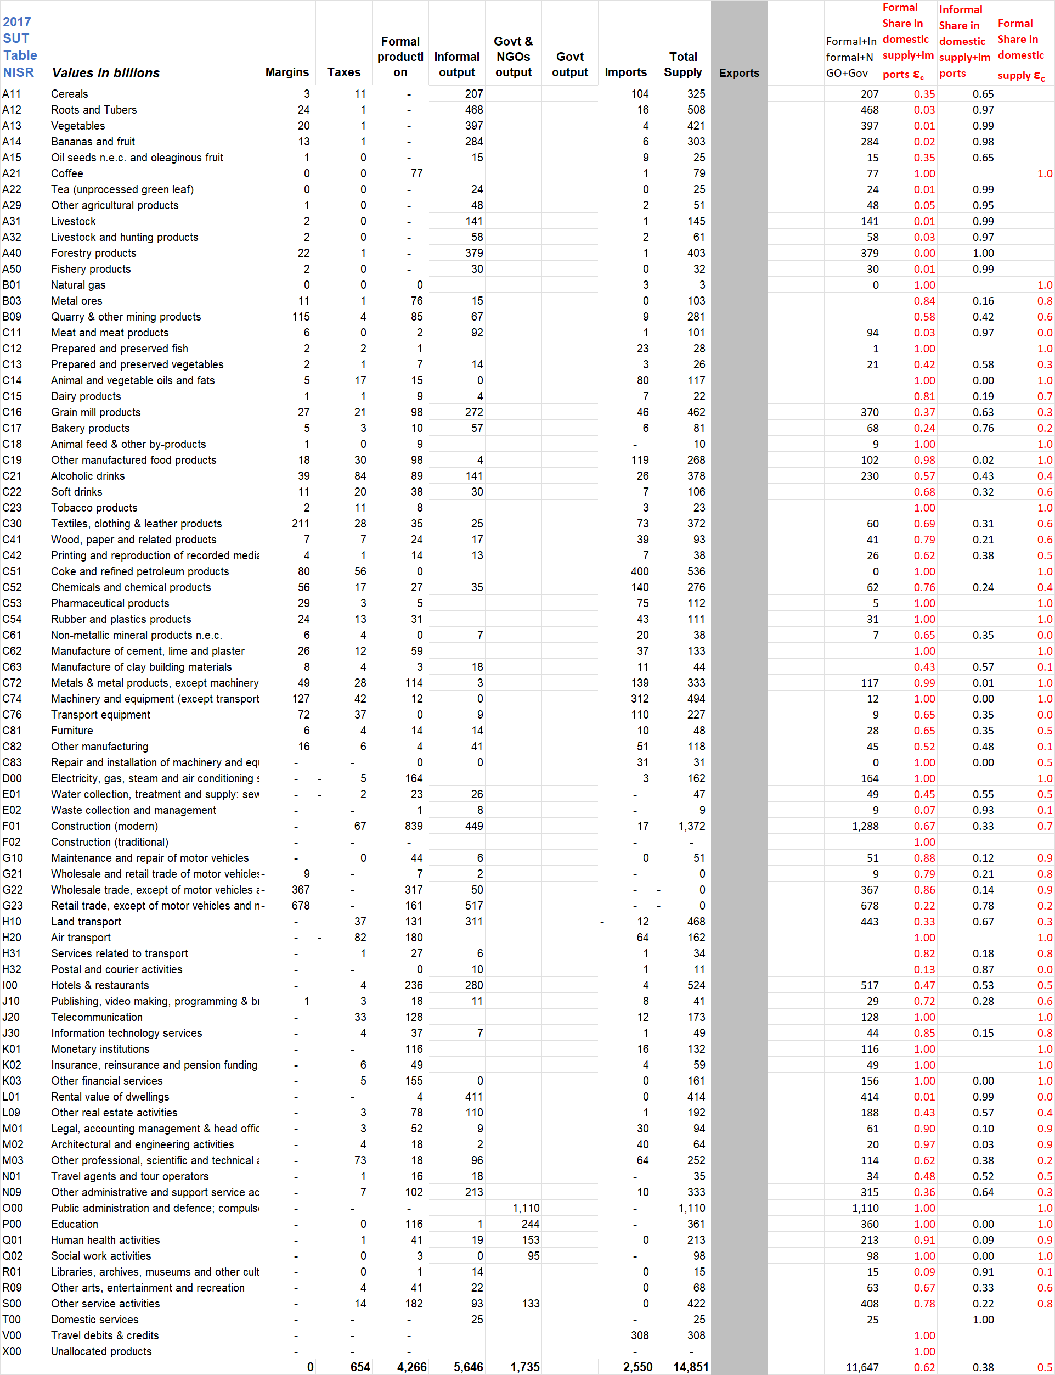

Table 2. Extract from Tax expend. Model: in/formal shares from NISR SUT2017 and exempted/zero-rated shares from RRA, 2017
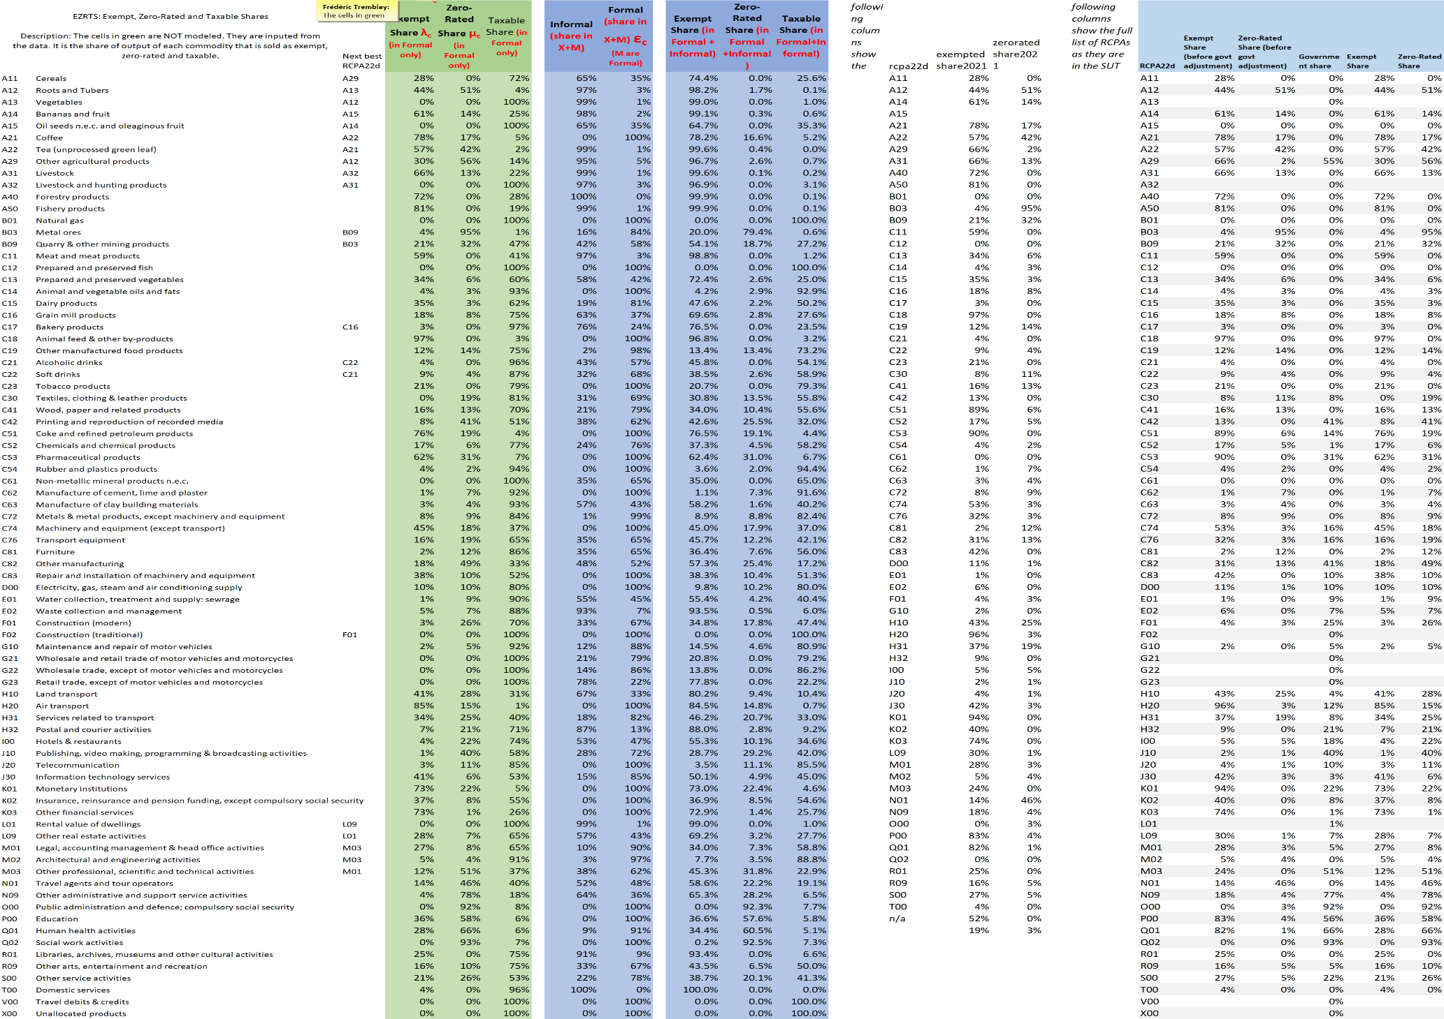

The SUT has the airline subsidy as one on ‘product’, but the SAM has it as one on activity; it seems to be neither since not based on transport services sold.
Also eq. (4) in “New model equations” seems tax-exclusive on the LHS, but tax-inclusive om the RHS.
The current SAM calculates the VAT rate over total supply, i.e. as a % of the VAT-inclusive price. For the model, the rates are calculated as a % of the VAT-exclusive price: vat’ = vat/ (1 - vat) with vat the rate in % of VAT-inclusive price.
PA is also determined by export prices, which only depend on the exchange rate.
The Tax Expenditure model applies this simplification, short of data on in/formal section by type of demand.
To ease notation, we switch to c’: for intermediate sales the sum is taken over c, that is inputs c’ for the production of all X_{c}.

